LAPORAN SEMENTARA

1. Array

Source code:

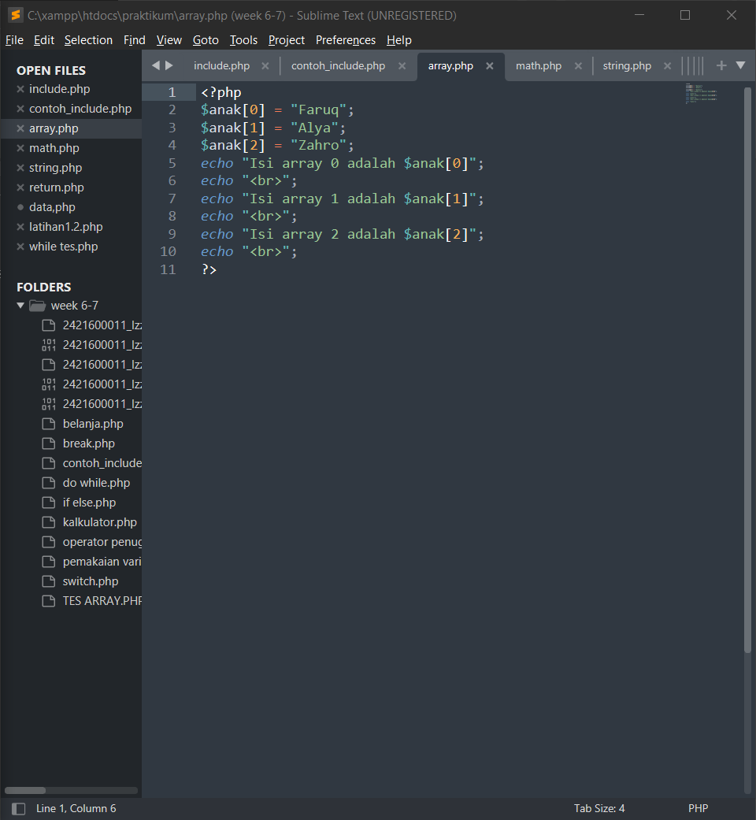

Result:

1. Built in math

Source code:

Result:

1. String

Source code:

Result:

1. Return value

Source code:

Result:

1. Modularisasi

Source code:

Result:

